Version: v.2 (CMS 5.4.3 November 2014)

**TEMPLACMS**

**Customer Portal  
User Guide**

COMMERCIAL STATEMENT

This document is subject to any terms as per [teamsoftware.com/legal](https://teamsoftwareinc-my.sharepoint.com/personal/keith_williams_teamsoftware_com/Documents/Desktop/Document%20Standardisation%20and%20Sharing/Already%20Updated/TEMPLA/TEMPLACMS/NEWSLETTERS/2021/DOCXs/teamsoftware.com/legal).

Table of Contents

Customer Portal 4

Login 5

Quality Audits 9

Clients 11

Contracts 13

Sites 19

Employees 23

Service Requests 25

Workbills 26

T&A and T&T Details 28

Quick View 31

Sub-User Administration 31

Logoff 33

# Customer Portal

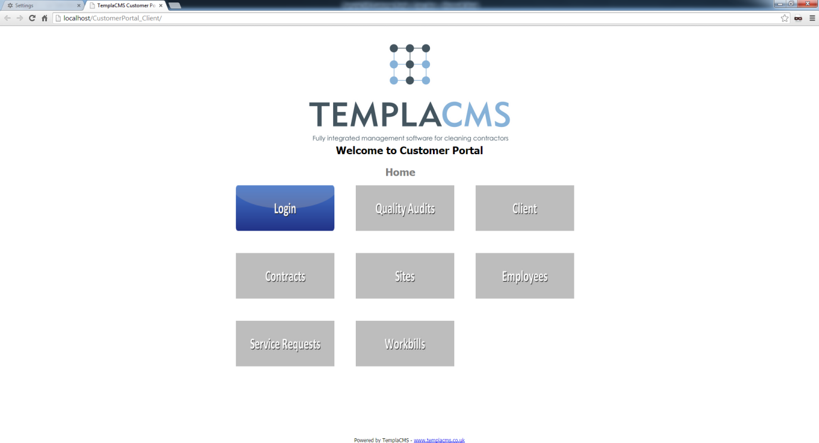

## Login

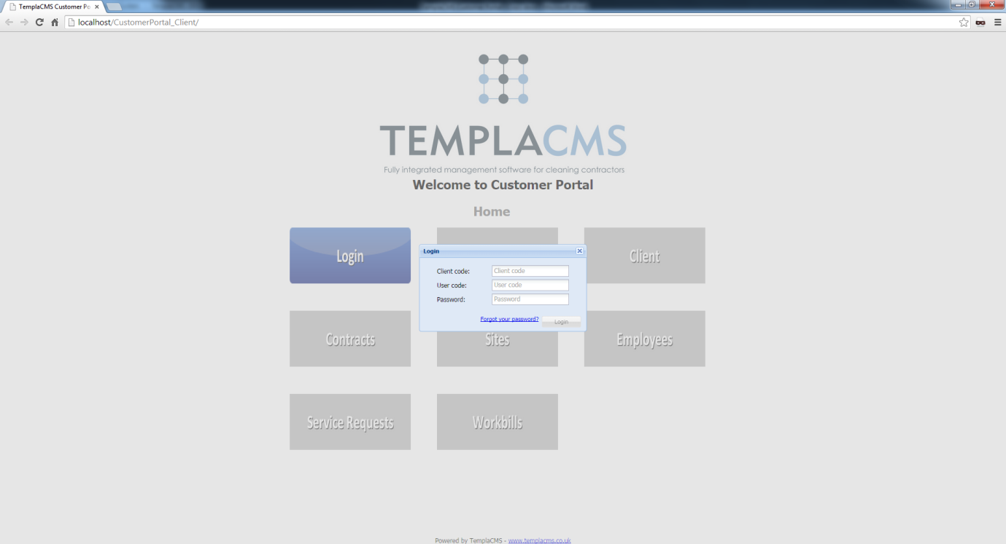

**Client code:** The user’s nominated client code

**User code:** The user’s specific user code, initially defaulting to the client code

**Password:** The user’s password, initially defaulting to the client code

The **Login** button will not be accessible until all of the above details are specified.

### First Login

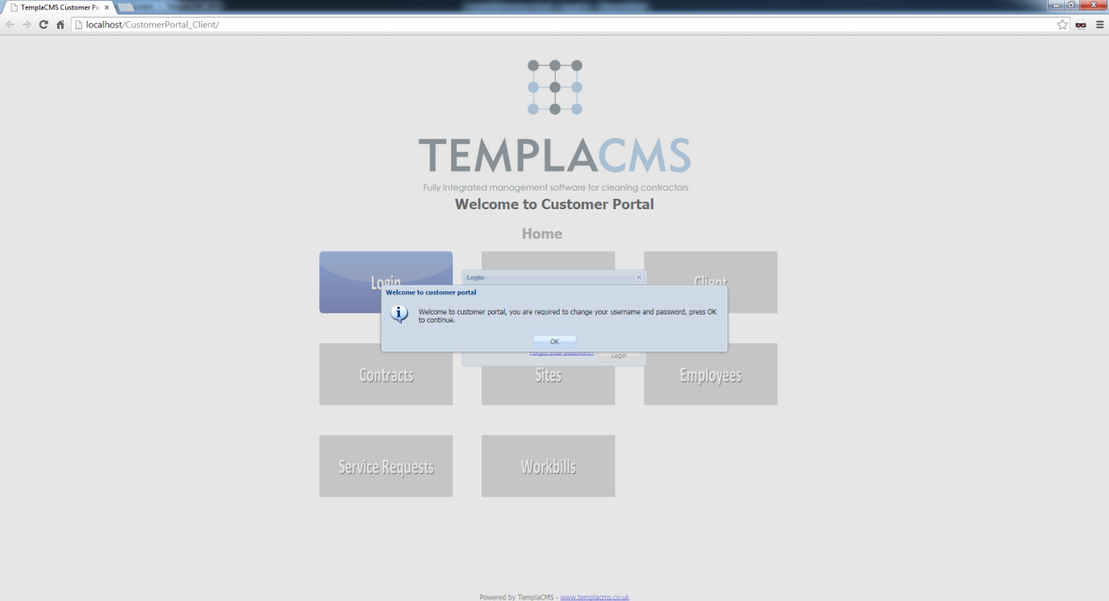

On first login, the user will be required to change their **user code** and **password**.

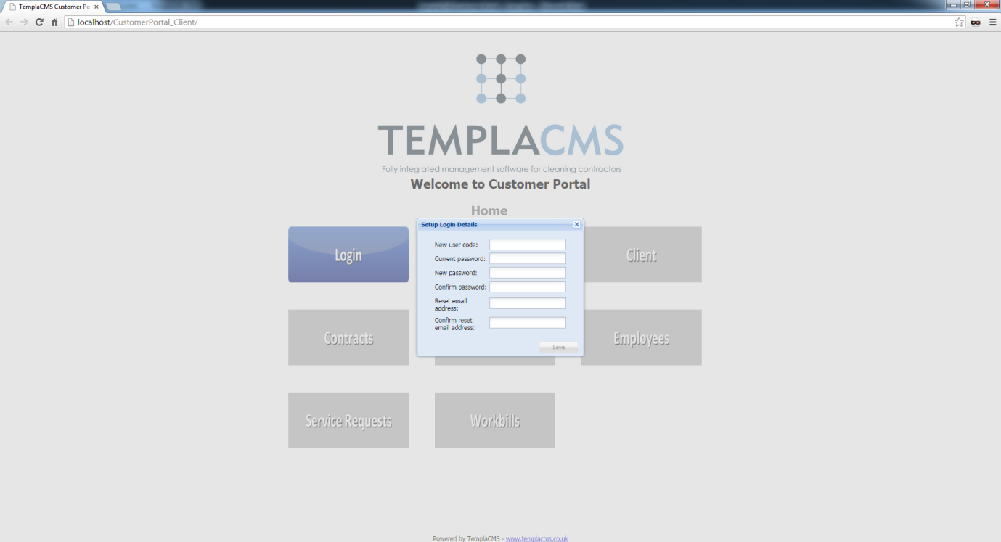

**New user code:** This will be the user’s code that they will use to login into TemplaCMS Customer Portal

**Current password:** The user will be required to enter their **current password**

**New password:** The user will be required to enter a **new password**, which will be checked for validity against prior retained passwords

**Confirm password:** The user will need to re-enter their **new password**

**Reset email address:** A valid email address will need to be entered, this email address will be the one used to send any forgotten passwords to

**Confirm reset email address:** The user will be required to re-enter their reset email address

The **Save** button will not be accessible until the user has entered all the information above.

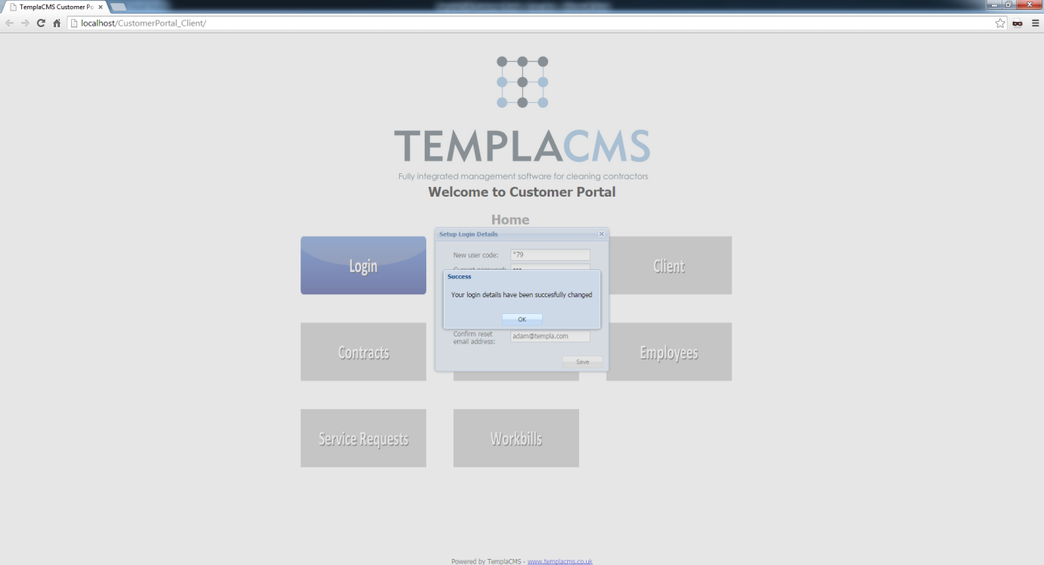

The details have now been successfully saved and the user will now be able to use the system.

### Forgot your password?

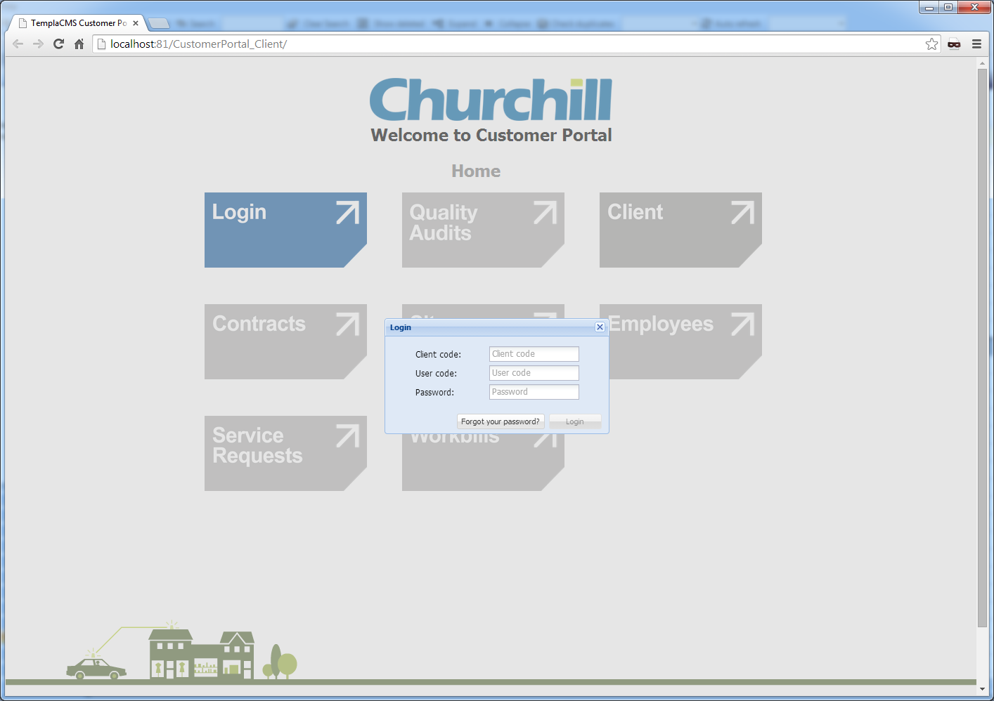

Select **Forgot your password?**:

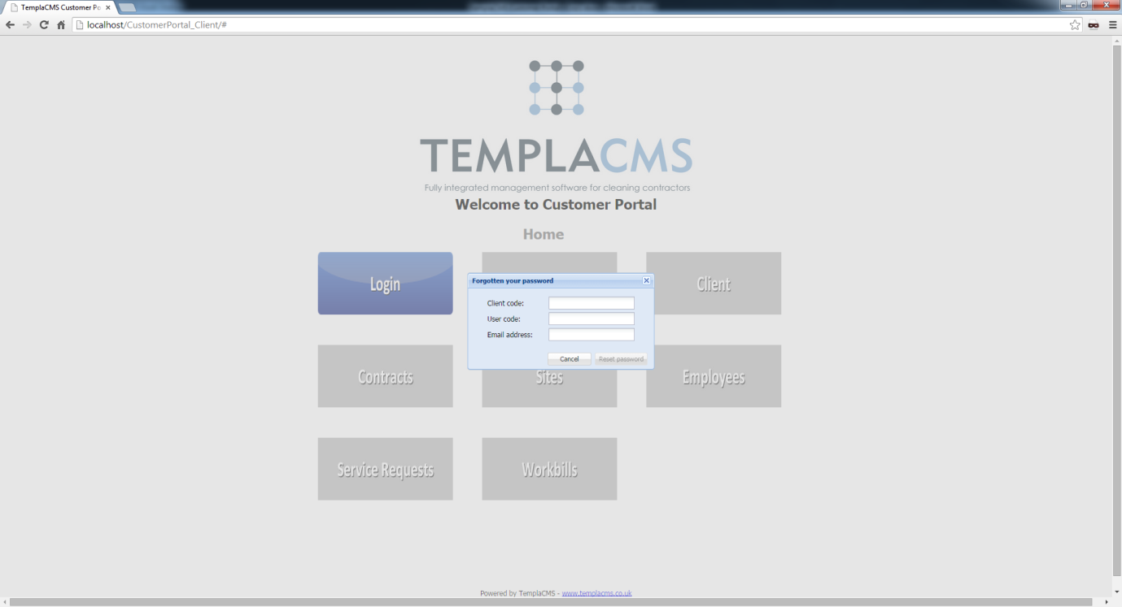

**Client code:** The user’s **client code**

**User code:** The user’s specific **user code**

***Email address:*** The user will need to enter the same email address that had originally been set up for password reset. An email will then be sent to this address containing a temporary password. Once successfully logged in, the user will be forced to change their password.

## Quality Audits

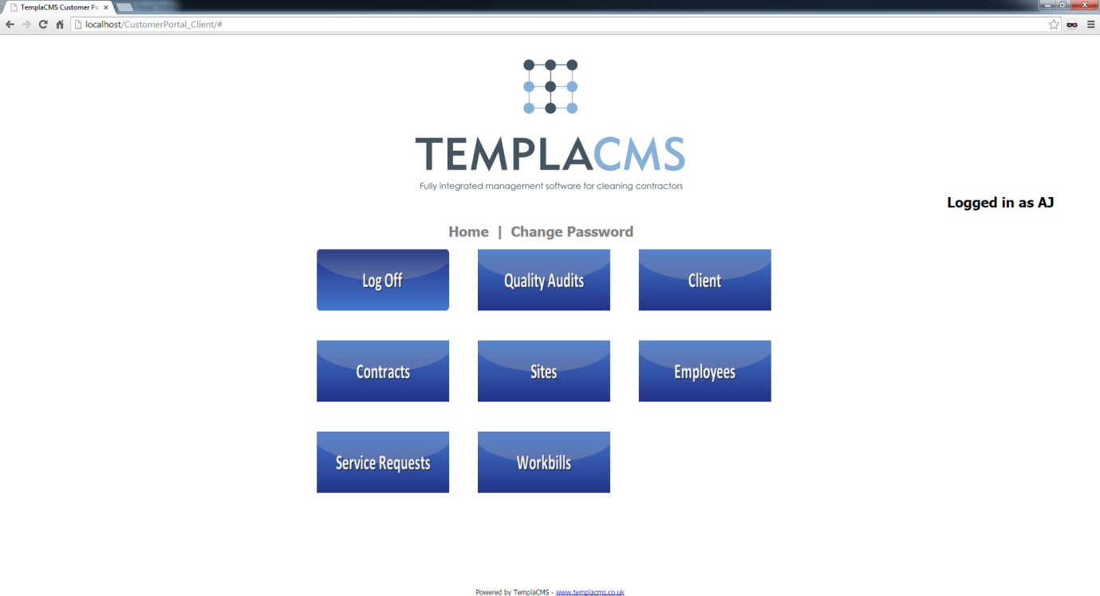

Access to the **Quality Audits** from the main page:

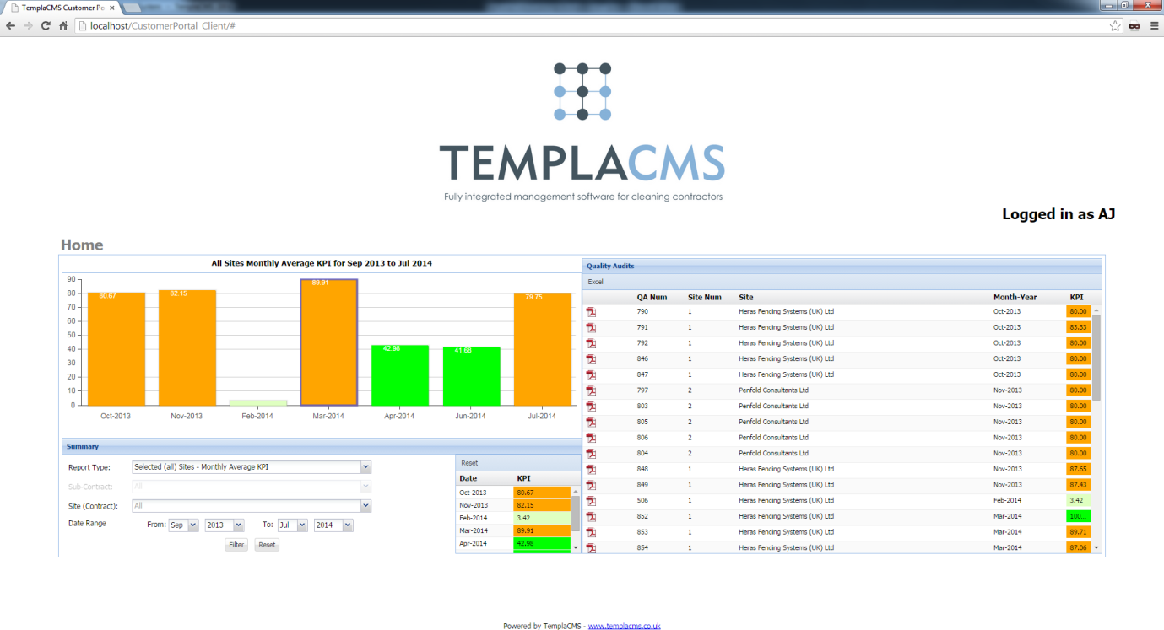

The **Quality Audit** view allows the user to access all their completed quality audits, defaulting to the **System Control** period range and the report type **Selected (All) Sites – Monthly Average KPI**. From here the user will be able to double-click on any quality audit form on the right-hand side and download a PDF file of the printed results. These are the same results that would have been sent at the time of audit completion.

### Quality Audits - Summary



On the left-hand side, the users can change the filter options that generate the summaries and detailed list.

**Report type:** This allows the user to select from three different report types:

* **Monthly KPI for Selected Site:**This enables a view of a single site across a date range, with summarisation by month, e.g. a 12-month summary. This willrequire the user to specify a site.
* **Selected (all) Sites – Single Month KPI**This enables a view of multiple sites across a month, with summarisation by site, e.g. 15 sites for June. This will require the user to set the date range to a single month.
* **Selected (all) Sites – Monthly Average KPI (default)**This enables a view of multiple sites across a date range, with summarisation by month, e.g. 15 sites in a 12-month summary.

**Site (Contract):** This allows the user to select a single **Site (Contract)** to filter by, where only the quality audits that are for that specific **Site (Contract)**will be displayed.

**Sub-contract:** This only allows the client administrator to select a specific sub-user to filter by, where only quality audits for that the selected sub-user will be displayed.

**Date Range:** The date range allows the user to specify the **From** month and year and **To** month and year, where the quality audits completed in that date range will be displayed.

## Clients

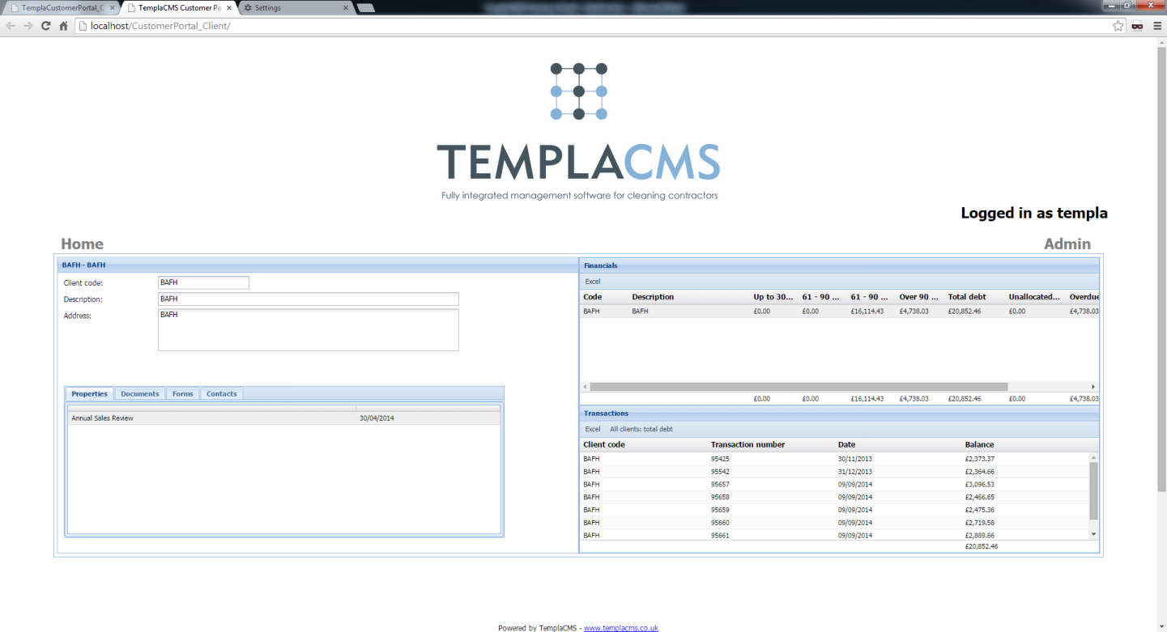

The **Client** view allows the user to access the client financial details, properties, documents, data forms and contacts.

### Clients – Financials

The **Client Financials** view displays the aged debt of the master client and any linked clients. By double-clicking in any of the aged debt cells the **transactions** grid is filtered to only show the transactions that make up the aged debt cell value.

Both the **financials** and **transactions** grid can be exported to an Excel spreadsheet.

### Clients – Properties

**Client properties** can be viewed via the **property** grid, only the master client property values are displayed here.

### Clients – Documents

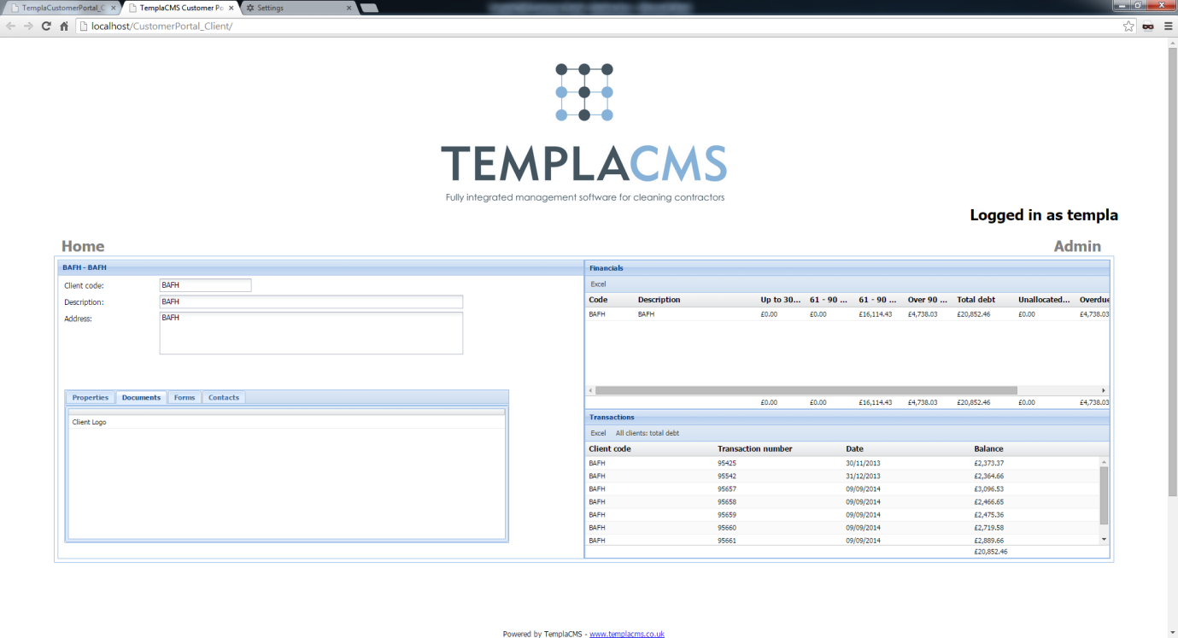

The **Client Documents** grid displays any attached items for the master client, double-clicking a row, will download the attachment.

### Clients – Forms

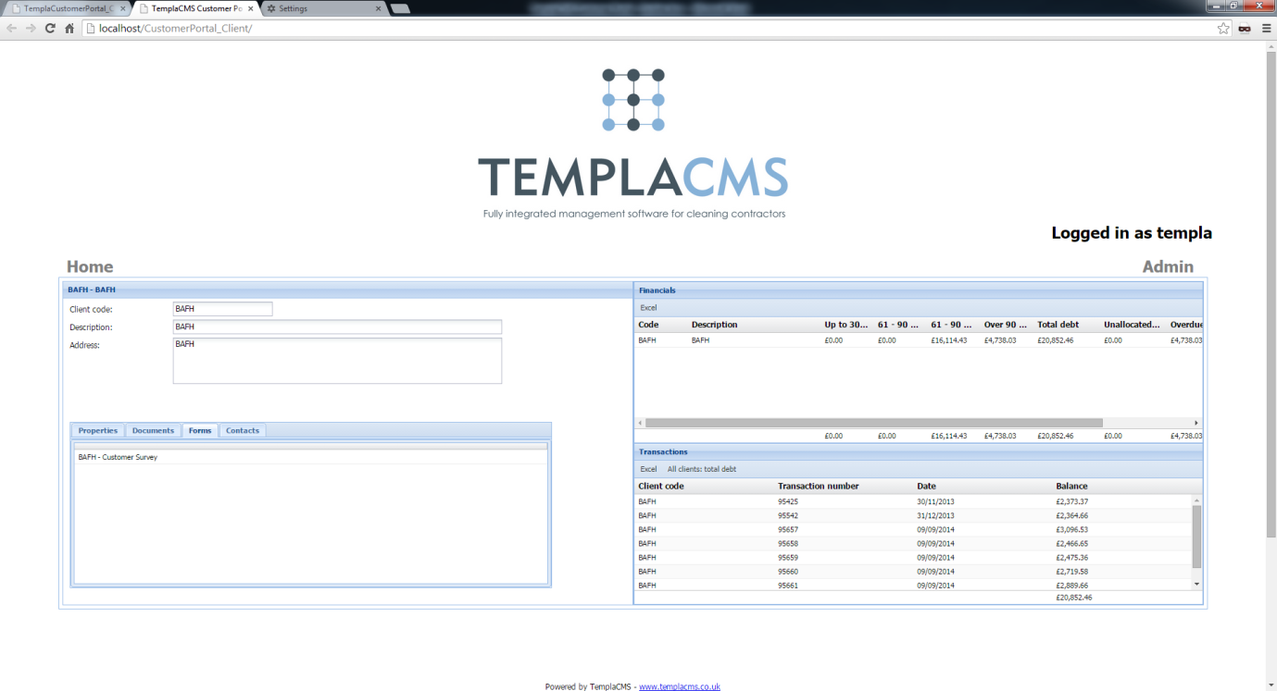

The data forms grid displays any data forms for the master client. Double-click the data form in the grid to download the PDF.

### Clients – Contacts

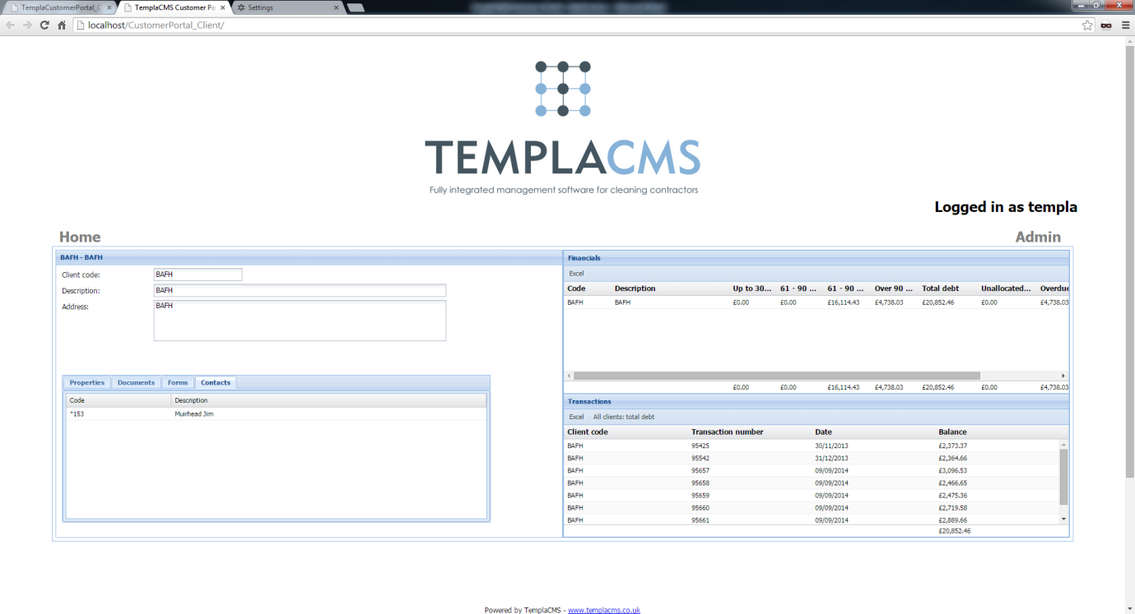

The **contacts** grid displays all contacts that have been added for the master client. Double-click on a contact   
row, Customer Portal will display the full client details.

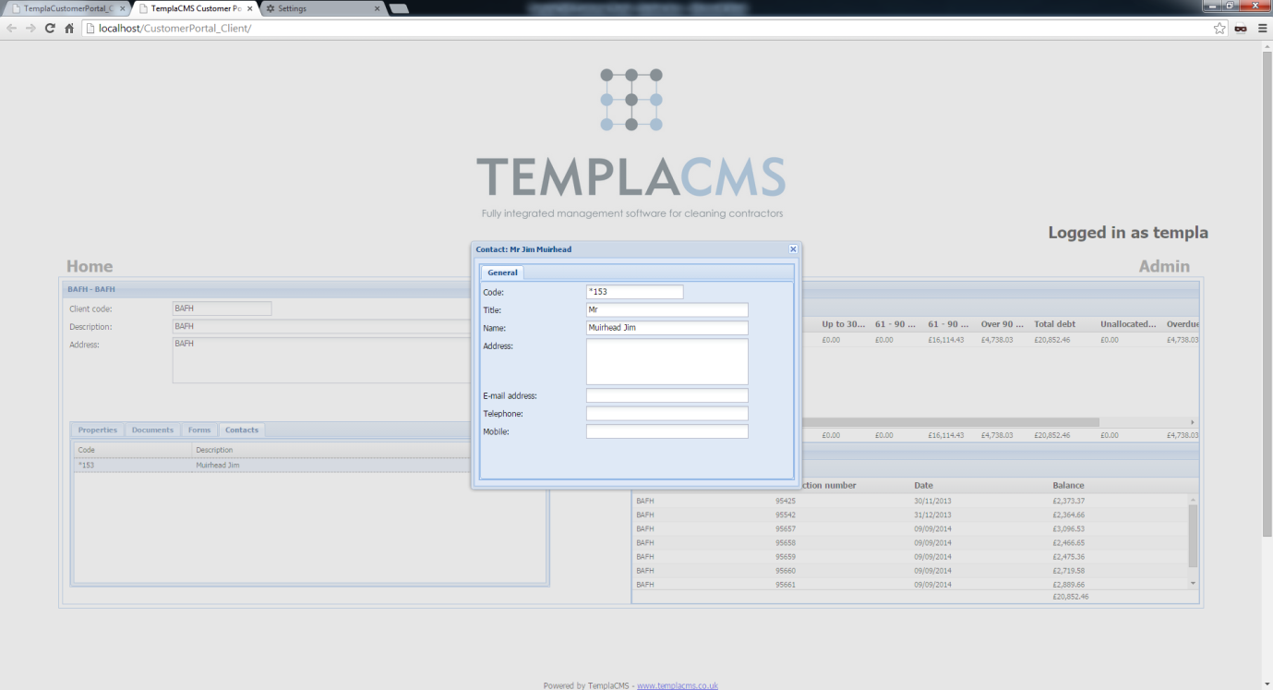

## Contracts

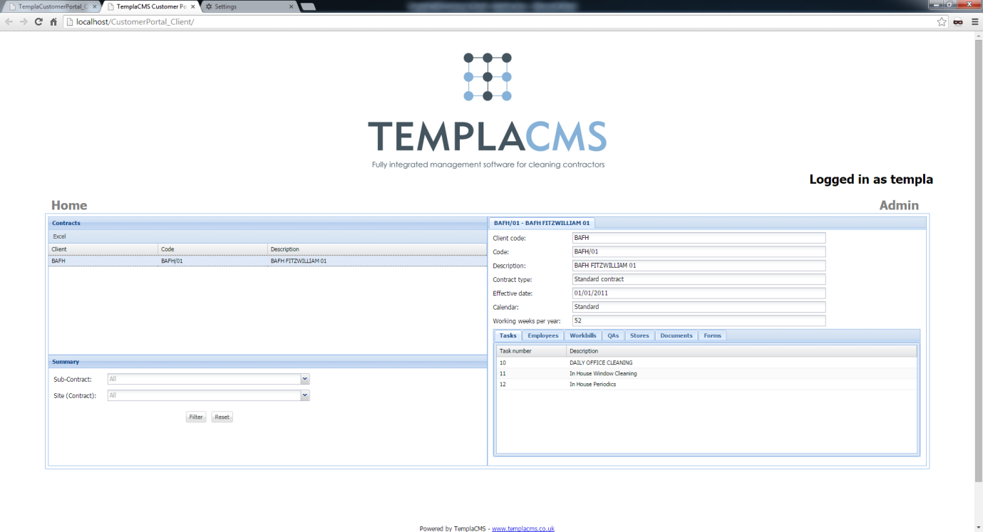

The **Contract** view enables the user to view all contracts for the master client and any linked client.

Users can view **Task, Employee, Workbill, QA, Stores, Documents** and **Data form** information for the selected contract.

The left-hand side of the view displays all contracts. Underneath the grid, a user can filter the contracts that are shown above.

The **Sub-contract** option allows the admin user to display all contracts that a sub-user is allowed to view.

The user can also filter down to all contracts for a specific site by using the **Site (contract)** drop-down list.

The entire contract grid can also be exported to Microsoft Excel.

### Contract – Tasks

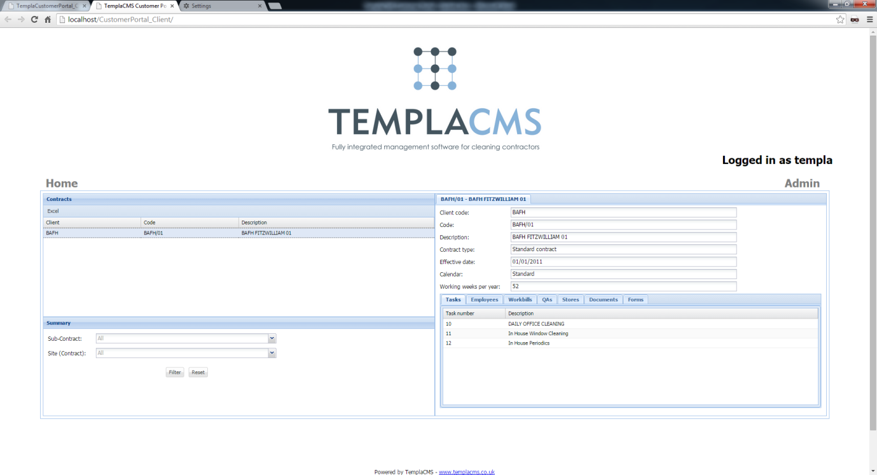

The **Contract Task** grid displays all contract tasks details. The user can double-click a row in the grid to open the   
full task details.

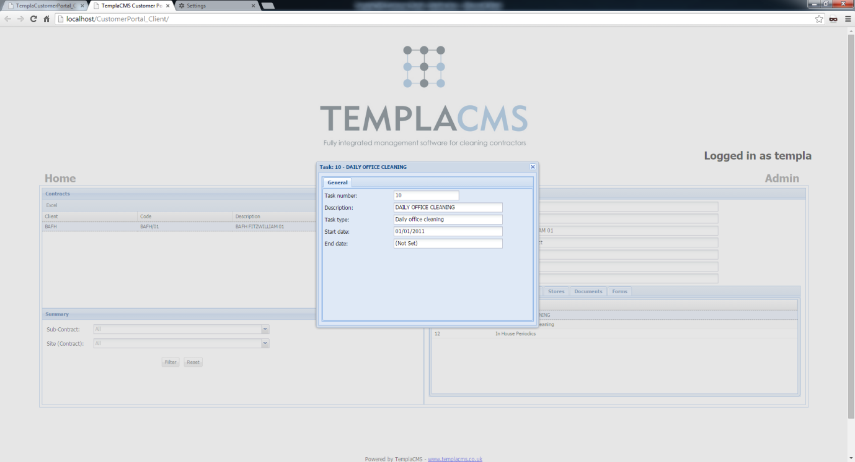

### Contract – Workbills

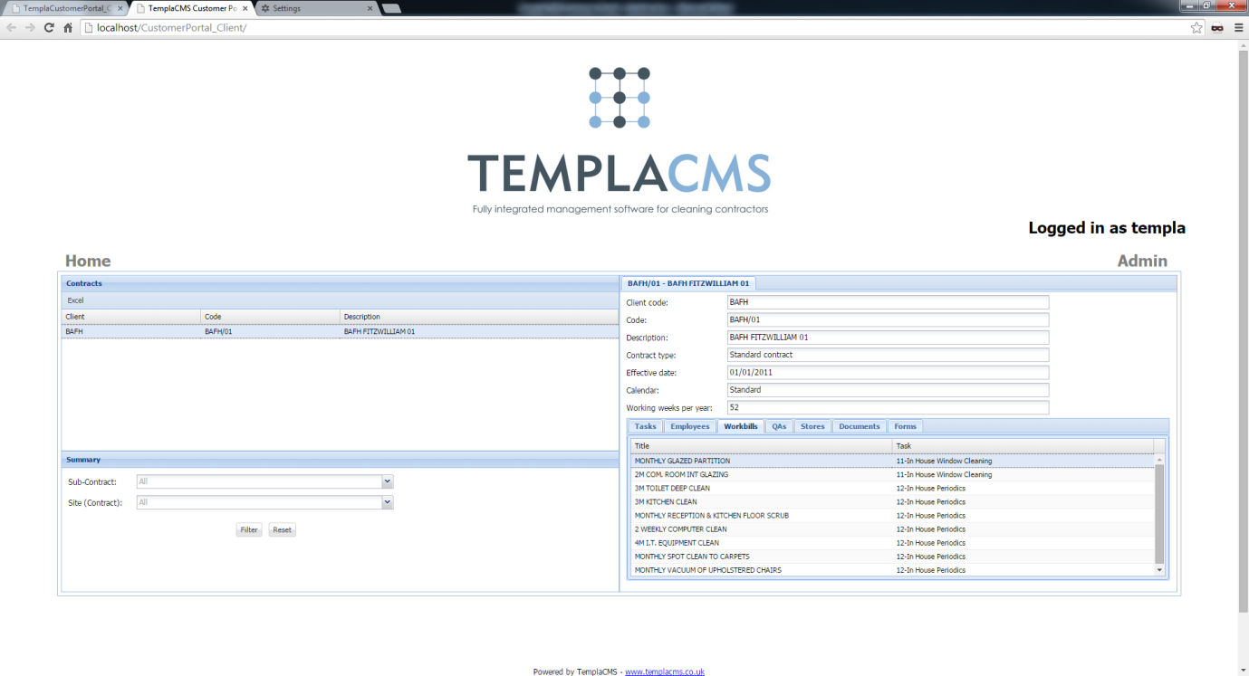

Users can view all contract **workbill** details. The user may double-click a contract **workbill** where the Customer Portal will display the full contract **workbill** details.

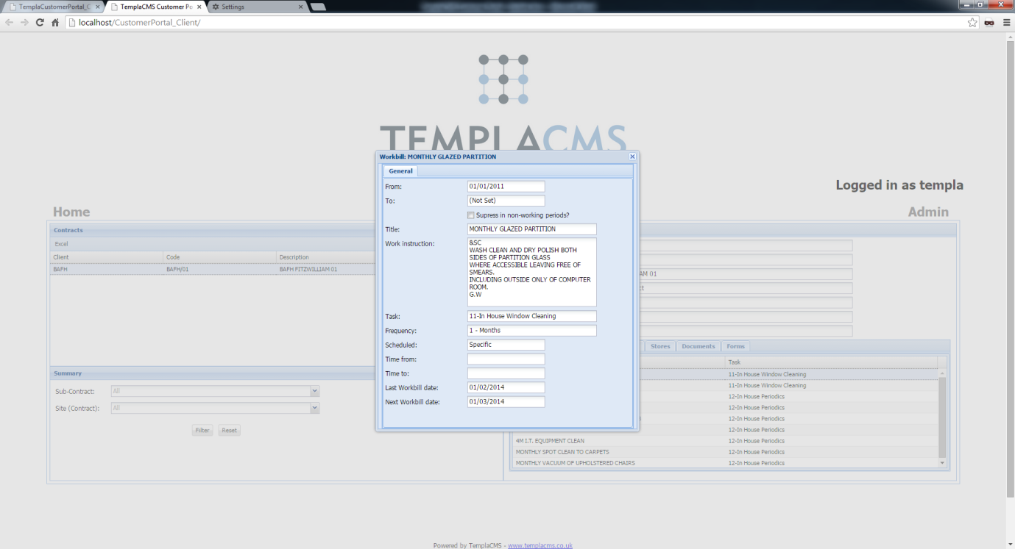

### Contract – QA

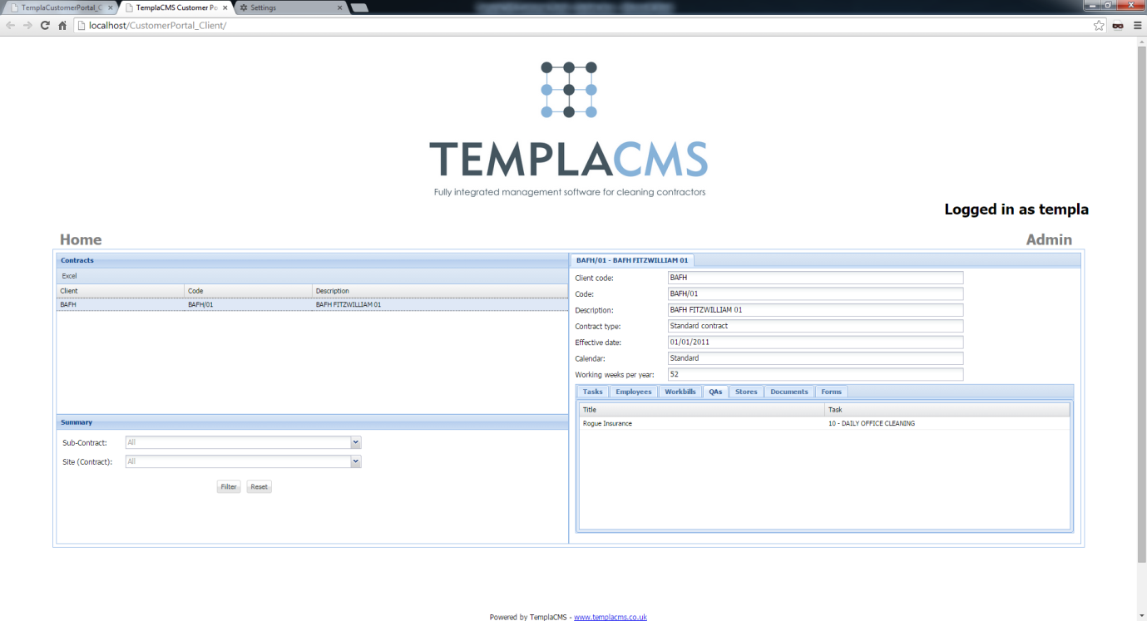

The contract **QA** grid displays all contract **QA** details. The user can double-click a contract **QA** to view the details.

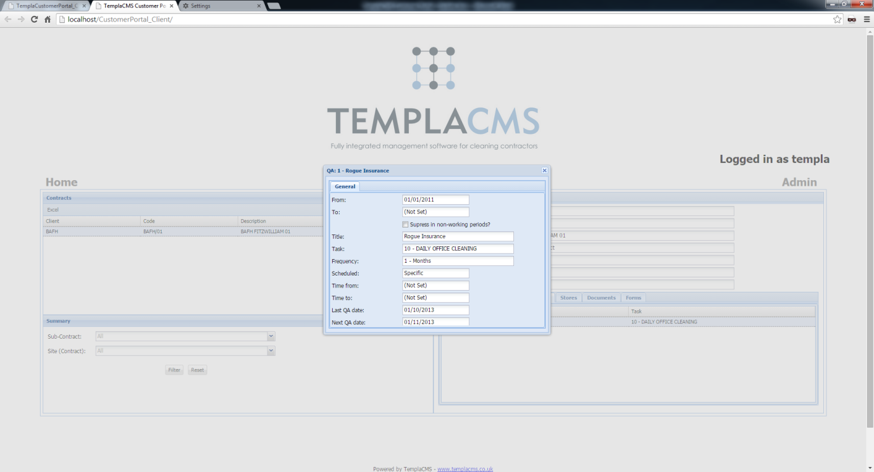

### Contract – Stores

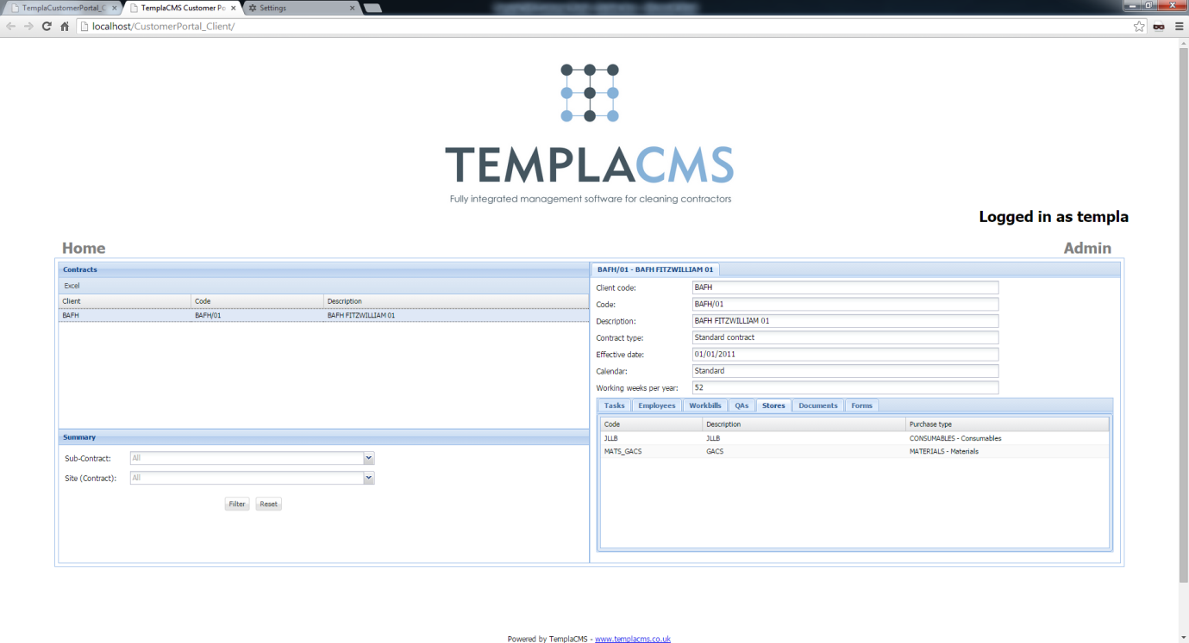

The **contract stores** grid allows users to view all products that have been assigned to the selected   
**contract stores** template.

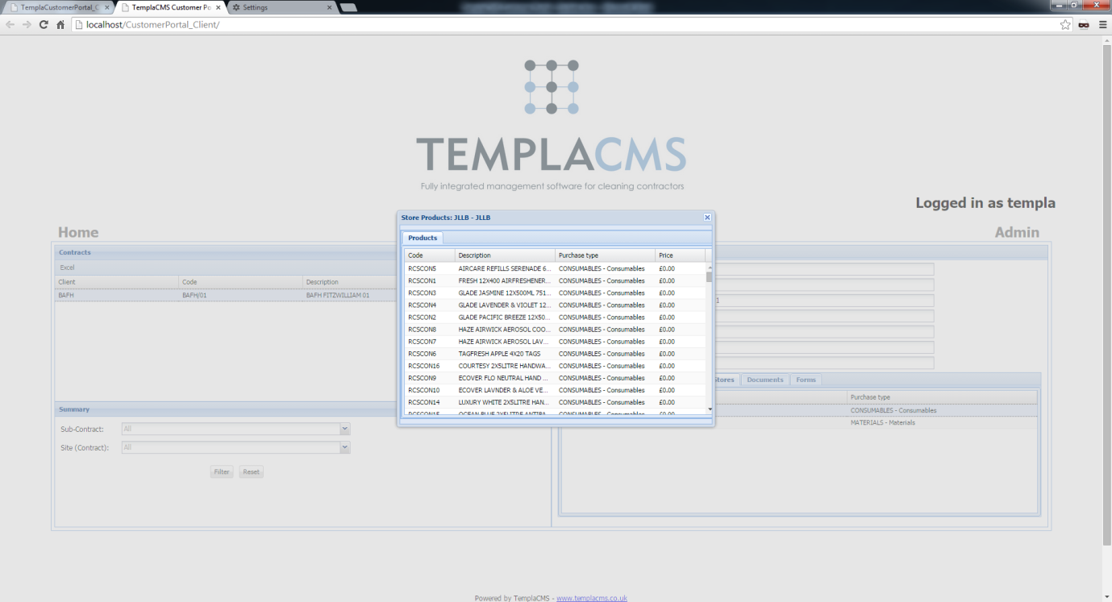

### Contract – Documents

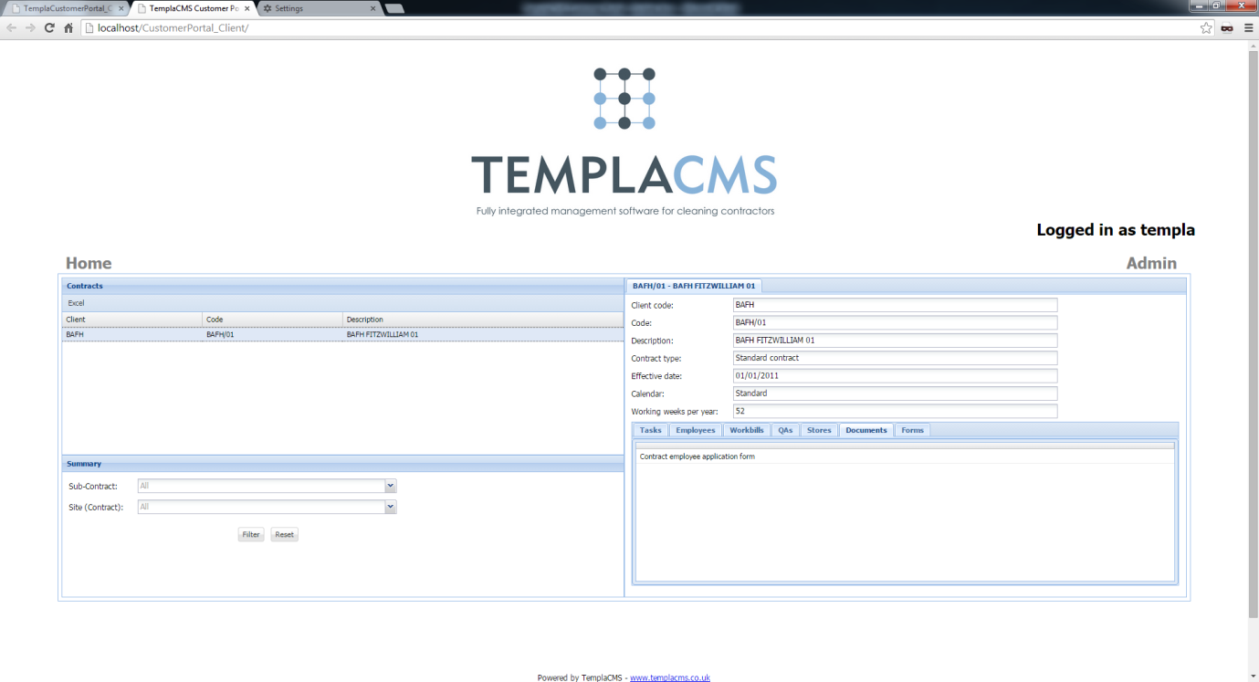

The **contract documents** grid displays any attached items for the contract. Double-click a row to download   
the attachment.

### Contract – Forms

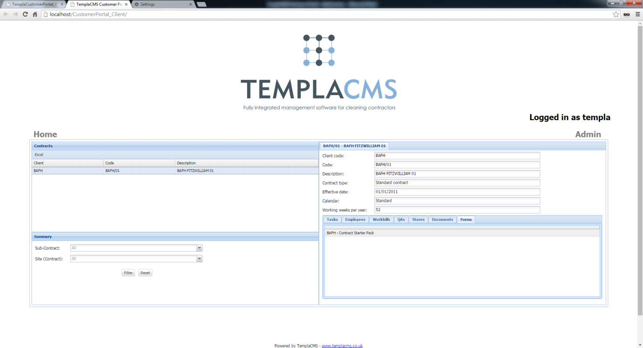

The **data forms** grid displays any data forms for the contract. Double-click the data form in the grid to download the PDF.

## Sites

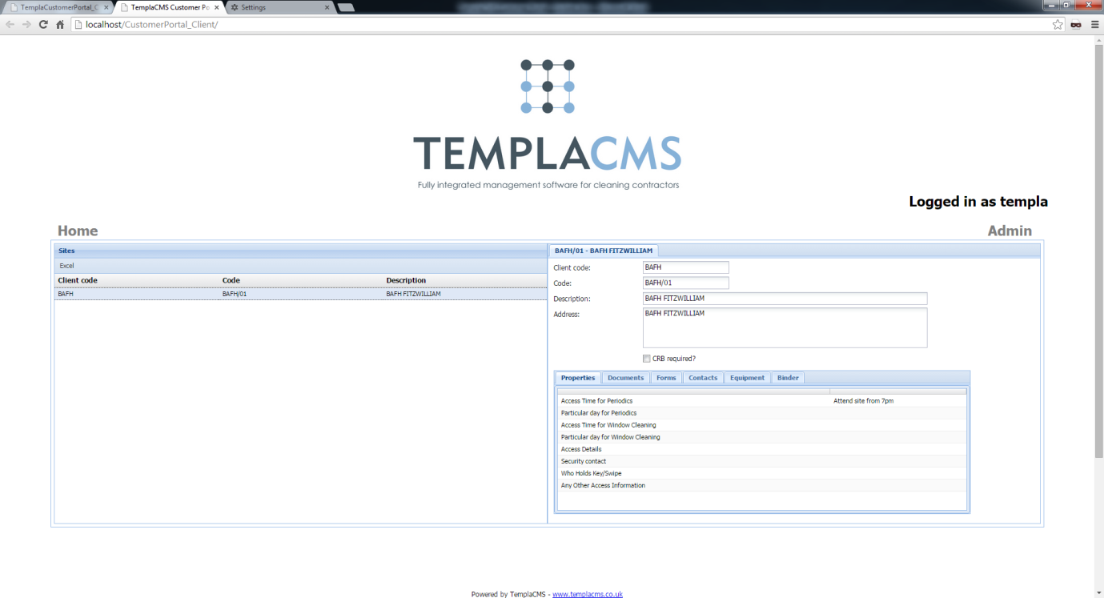

The **sites view** enables users to view site details for the master client and any linked clients. The **site** grid can be   
exported to Excel.

### Sites – Properties

**Site** properties can be viewed via the **property** grid.

### Sites – Documents

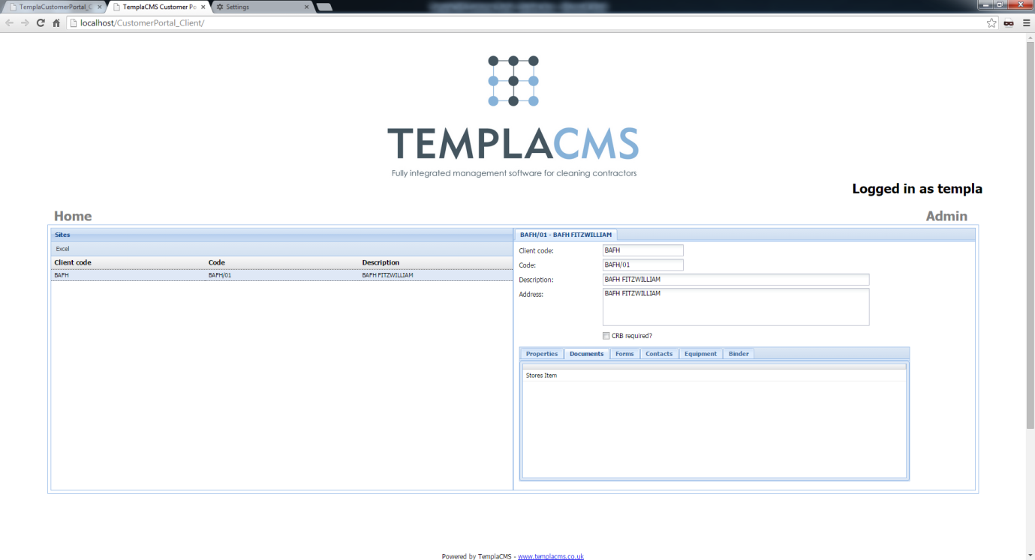

The **site documents** grid displays any attached items for the **site**. Double-click a row to download the attachment.

### Sites – Forms

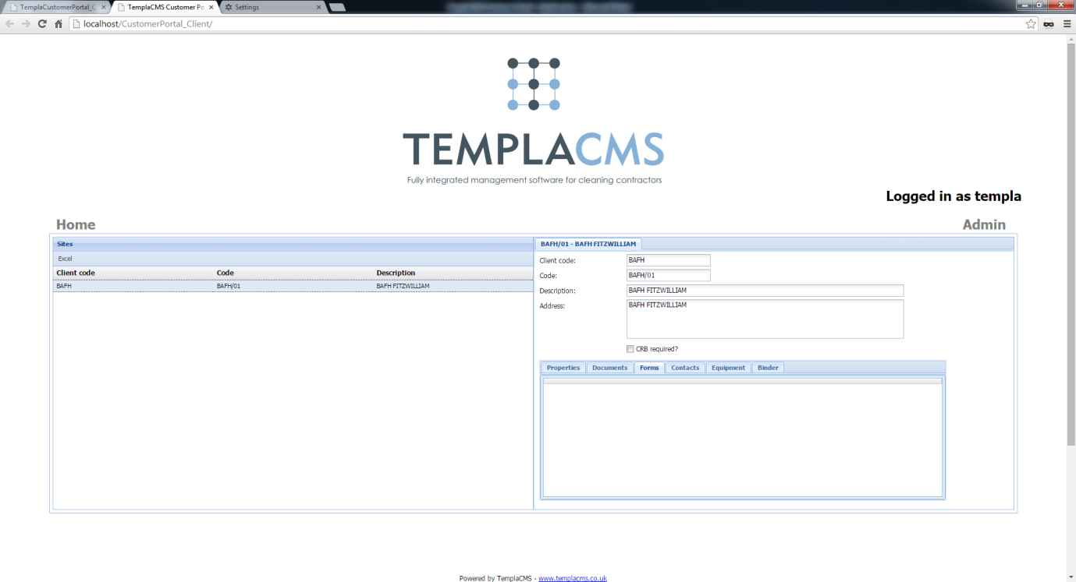

The **data forms** grid displays any data forms for the **site**. Double-click a **data form** in the grid to download   
the PDF.

### Sites – Contacts

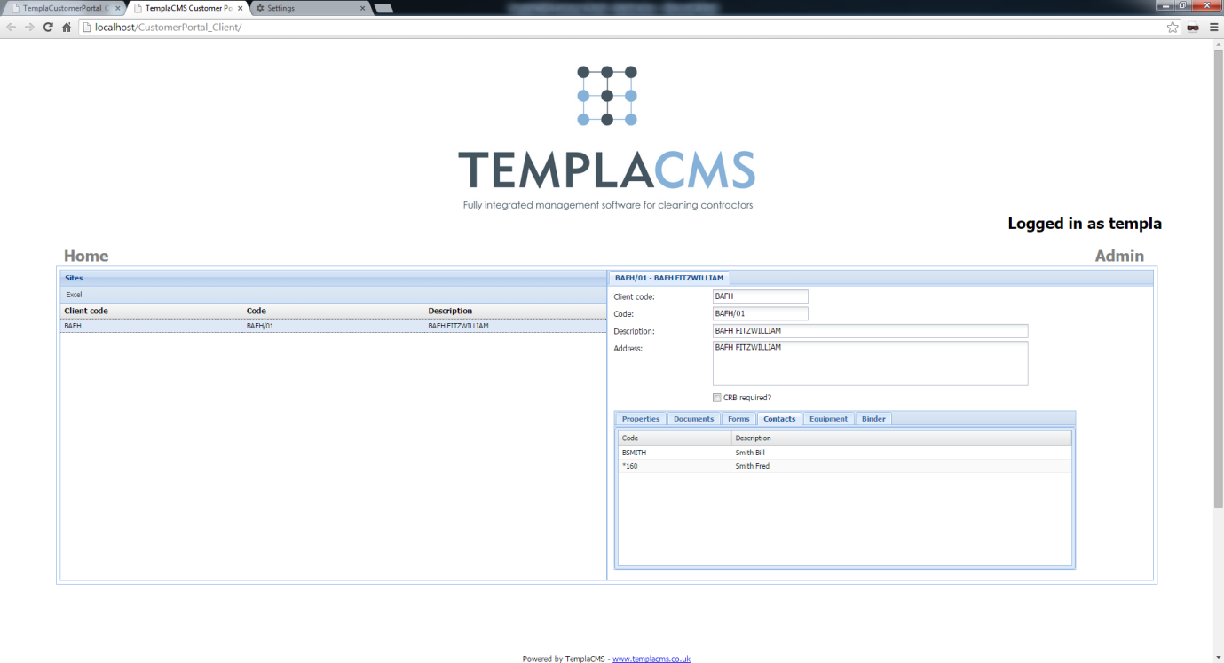

The **contacts** grid displays all contacts that have been added for each **site**. Double-click a contact row to display the full   
client details.

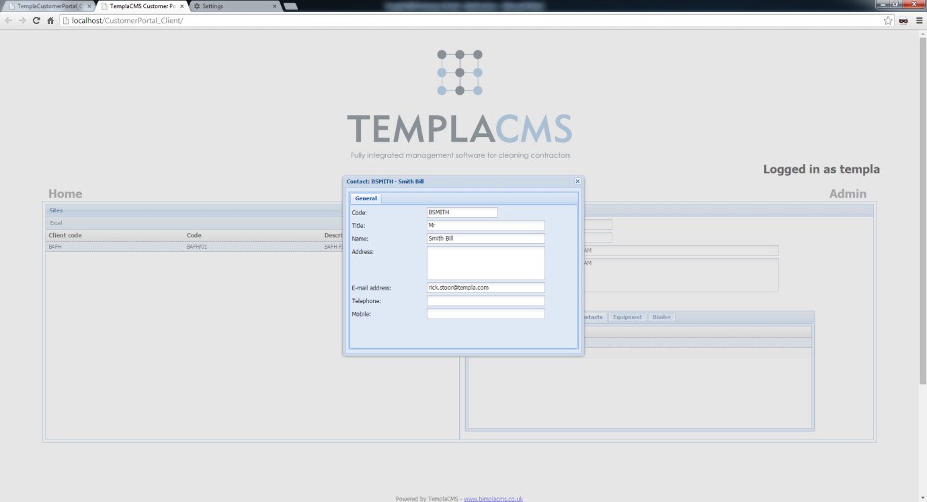

### Sites – Equipment

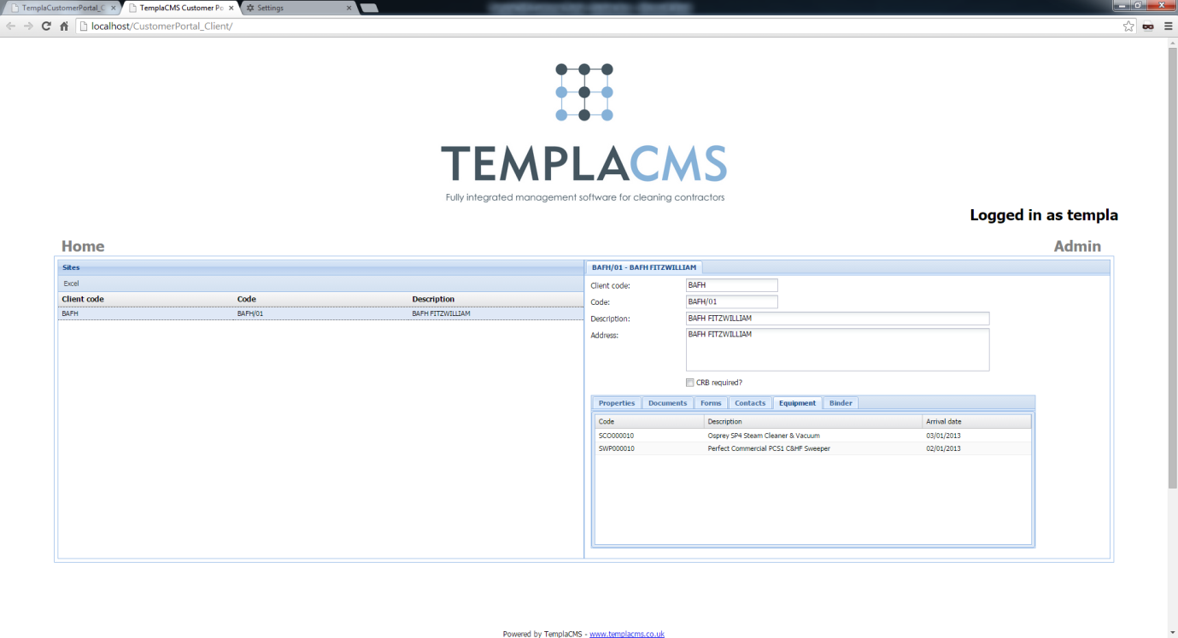

The **equipment** grid displays all equipment items that are assigned to the site. Double-click the equipment row to display the full equipment details. This including the PAT details and any attached documents which when selected will be downloaded.

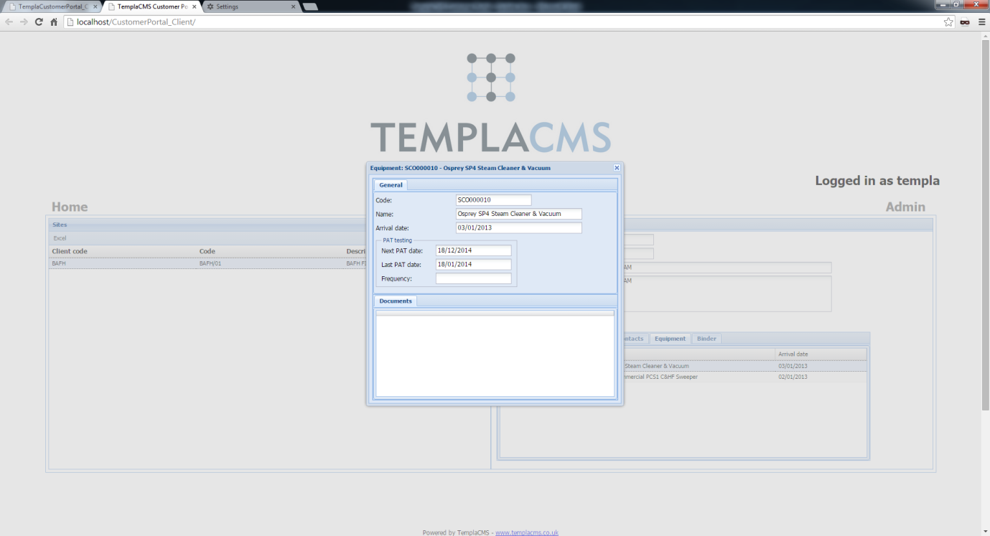

### Sites – Site Binder

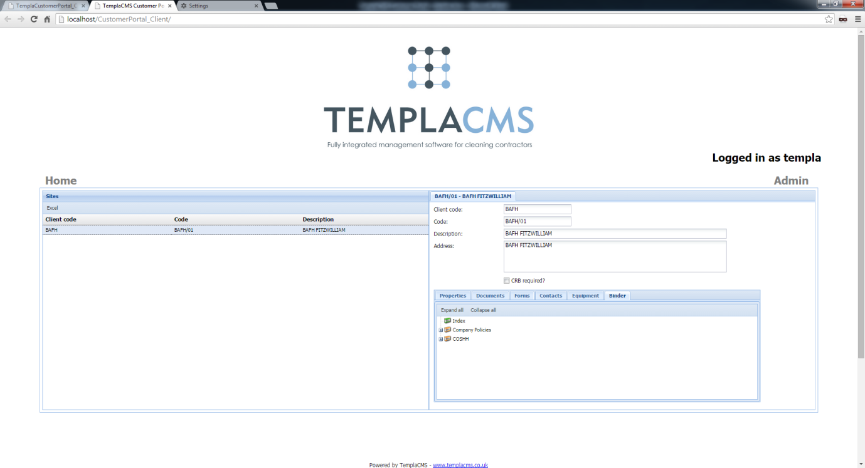

The **site binder** displays attachments in a folder structure. An attachment can be selected to be downloaded.

## Employees

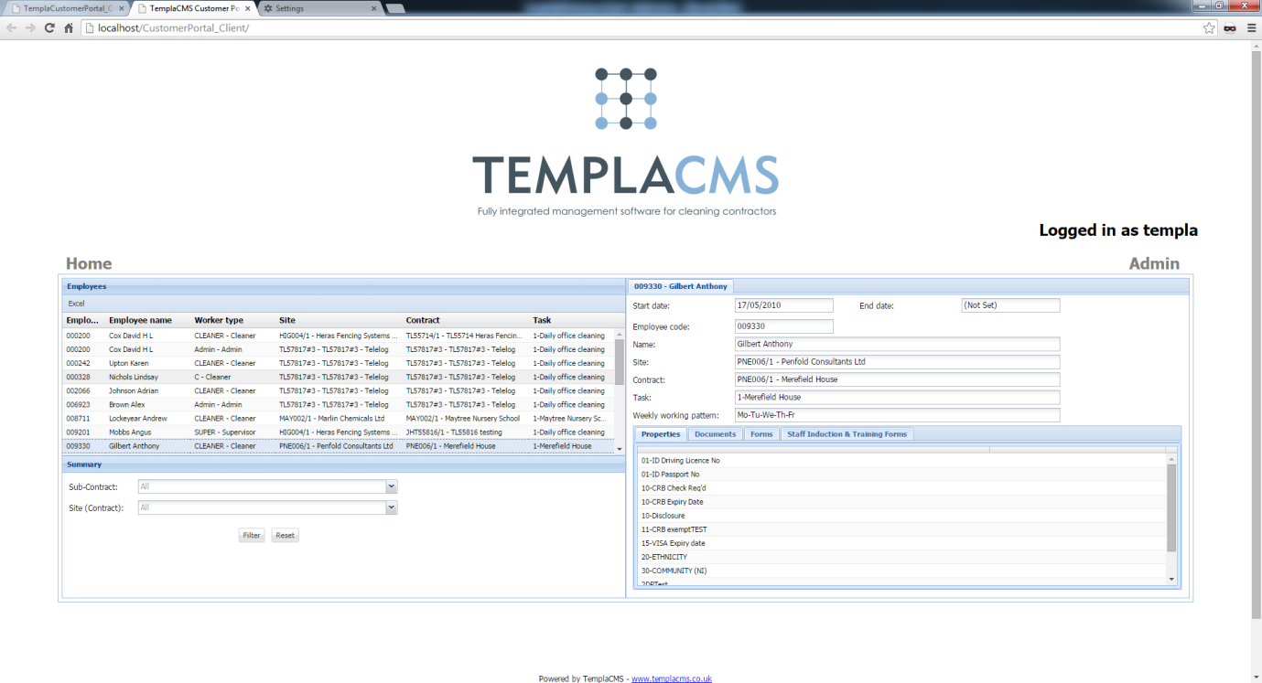

The **employees** view enables users to view employee details for the master client along with any linked clients. The **employees** grid can be exported to Microsoft Excel.

### Employees – Properties

**Employee properties** can be viewed via the property grid, on the right-hand side of the screen

### Employees – Documents

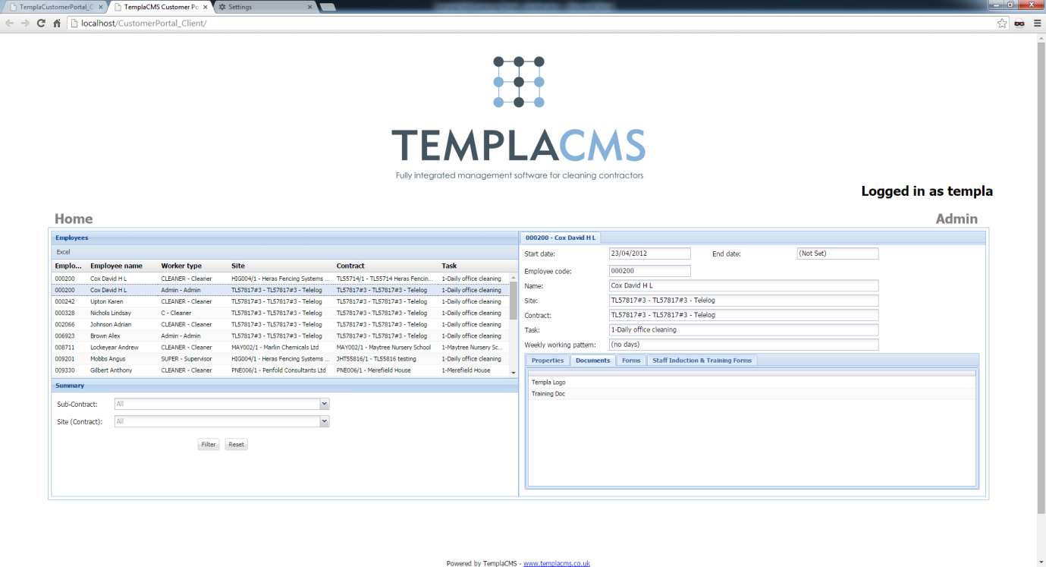

### Employees – Data Forms

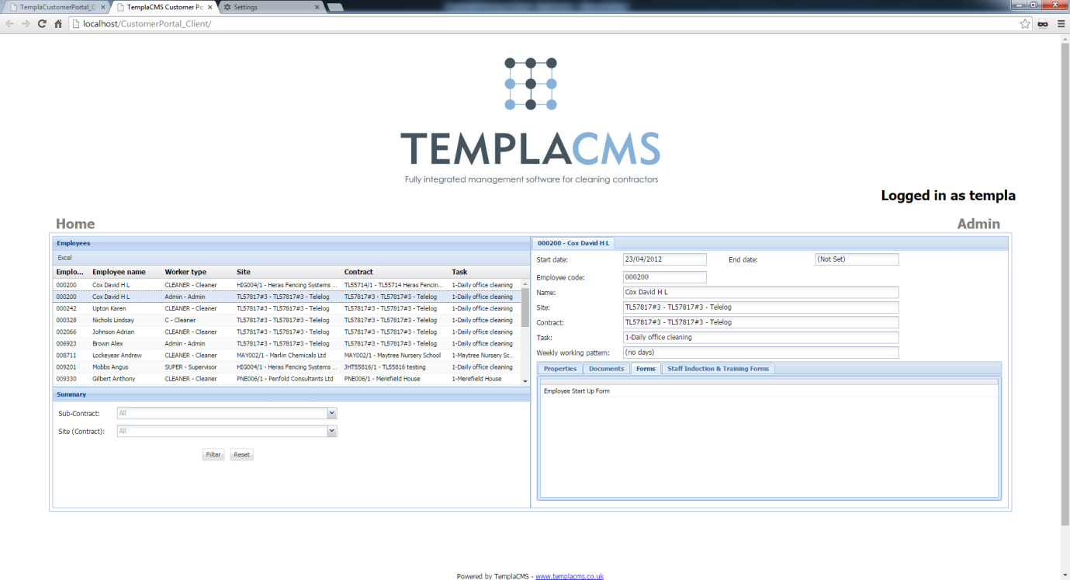

The **data forms** grid displays any data forms for the employee. Double-click a data form in the grid to download the PDF.

### Employees – Staff Training

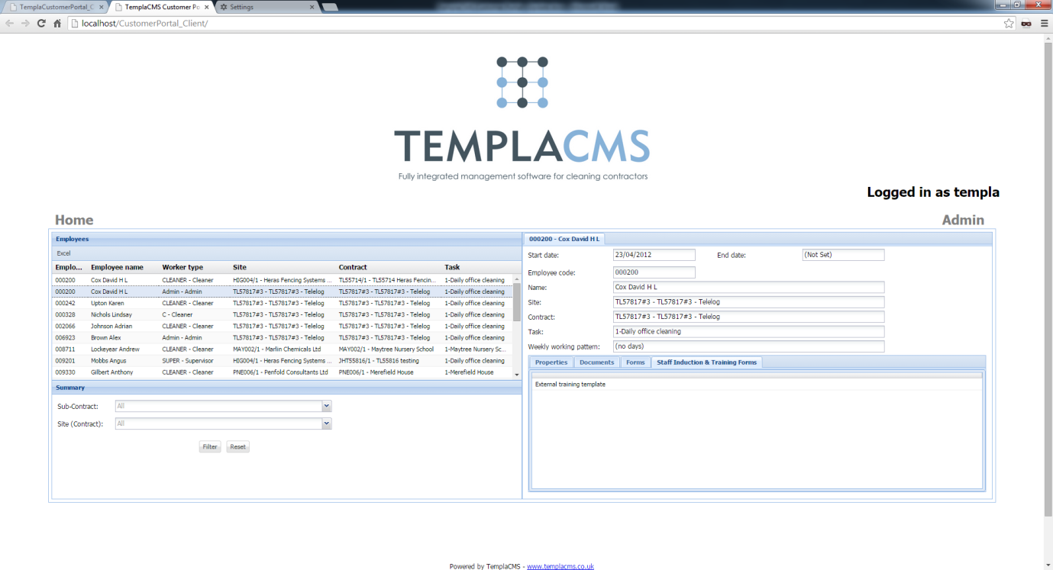

The staff training grid displays all staff training forms that have been entered for the selected employee. Select the staff training form to download it.

## Service Requests

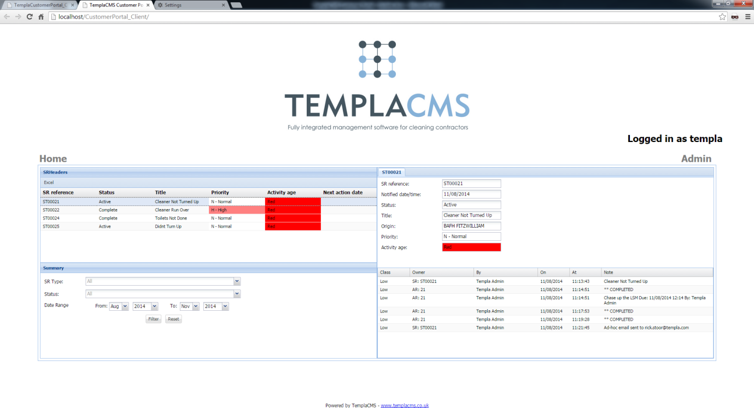

The **service request** view displays all service requests that are outstanding for the master client and any linked clients.

The left-hand side of the view displays all the service requests which can be exported to Microsoft Excel. Underneath there are controls that the user can use to filter the **service requests**.

The **Sub-contract** option allows the admin user to display all service requests that a sub-user is allowed to view.

The user can also filter down to all service requests for a specific site by using the **Site (contract)** drop-down list.

The right-hand side of the **service request** view displays the service request details along with all notes that have been entered. The user can read this to see what actions have been taken.

## Workbills

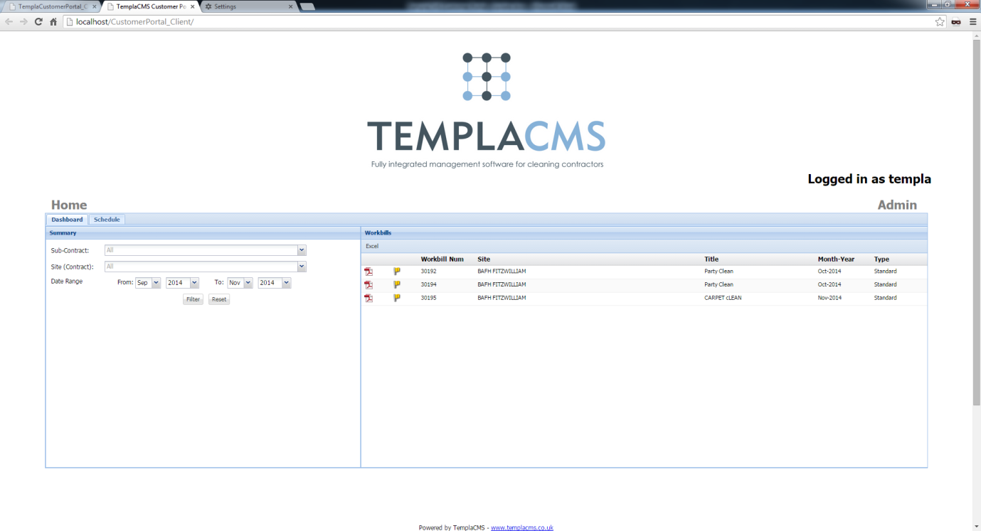

The **workbill view** displays all workbills that are associated with the master client or any linked client.

The left-hand side of the view allows the user to filter the **workbill** grid on the right-hand side of the view.

The **Sub-contract** option allows the **admin** user to display all workbills that a sub-user is allowed to view.

The user can also filter down to all workbills for a specific site by using the **Site (contract)** drop-down list.

The user can double-click a workbill row to download a copy of the workbill PDF.

### Workbills – Schedule View

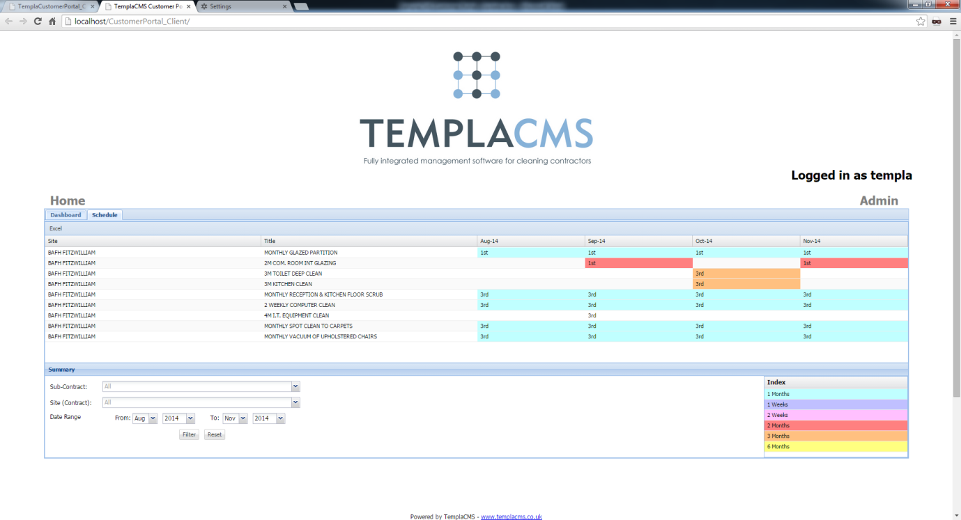

The **workbill schedule** allows users to view when future workbills are due to be carried out or when past workbills were completed.

The grid can be filtered using the following parameters.

The **Sub-contract** option allows the admin user to display all workbills that a sub-user is allowed to view.

The user can also filter down to all workbills for a specific site by using the **Site (contract)** drop-down list.

The **date range** can be set to only show workbills that will be or that have already been carried out within the selected date range.

The **frequency** colours have been defined within **System control** and cannot be changed within TemplaCMS Customer Portal.

When the user double-clicks a **month cell** in the grid, a popup will show all workbills that have been or are due to be carried out that month.

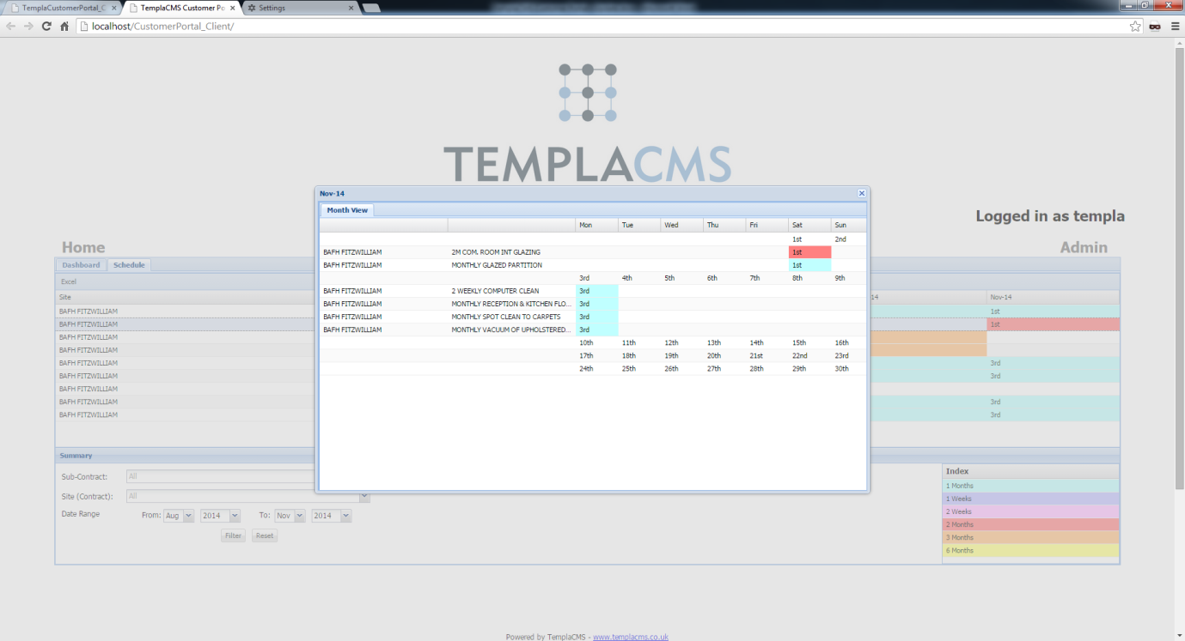

If the workbill has been created within TemplaCMS the user may double-click the workbill to download the workbill PDF. If, however, the workbill has not yet been created within TemplaCMS the following message will be displayed:

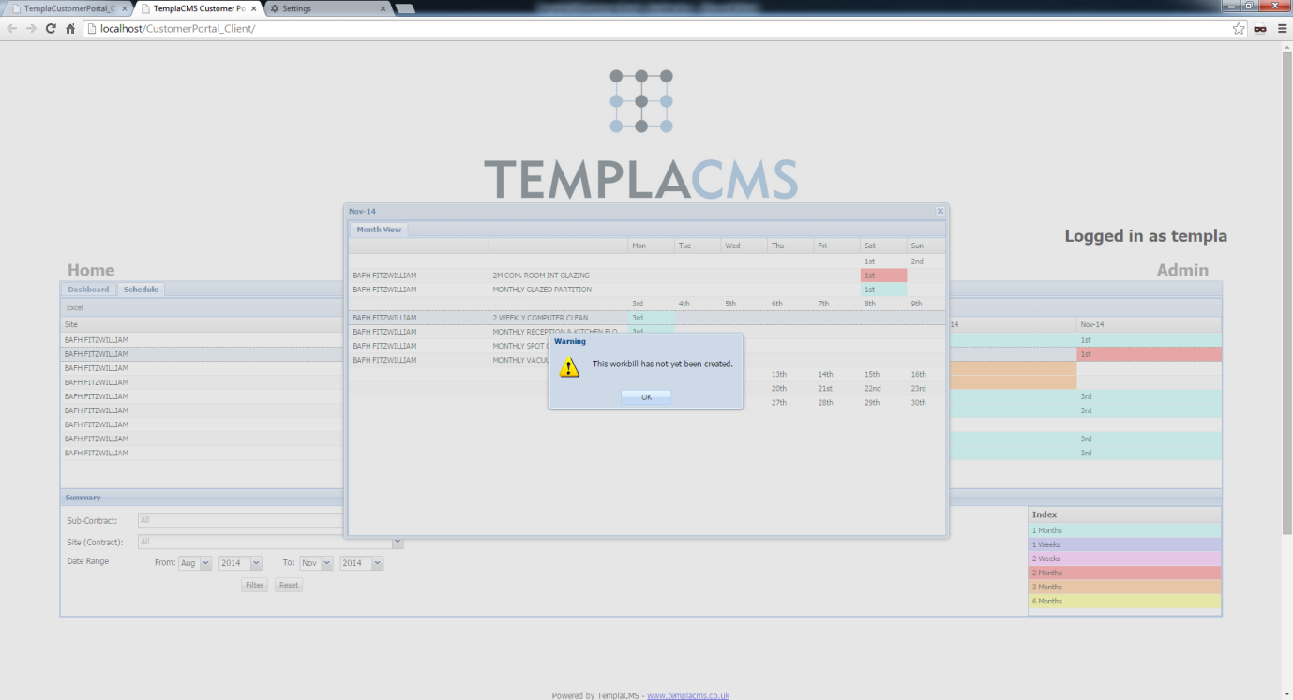

## T&A and T&T Details

**T&A** (Time and Attendance) and **T&T** (Tagging and Touring) details are both available on the Customer Portal. T&T details comprise the **Check Tag** data for specific **Site Locations** (e.g. Men’s Washroom, etc) that demonstrates presence at a certain date/time/location. Meanwhile, **T&A** data comprises clocking in/out details i.e. when employees start and end their shifts.

If enabled (through **System Control**) a tile for each of these options will appear on the Customer Portal Home Screen.

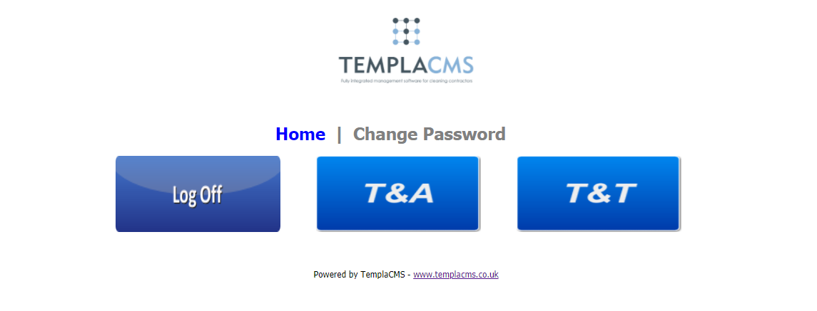

**Please Note**: If these tiles need to match your Customer Portal’s ‘look and feel’ your web designers will be able to replace the default ones with a design that aligns with your other tiles.

T&A Clocking

The **T&A** screen is displayed as shown below:

The filtering options are:

* **Report Type** - this will control the graph options which include:
  + **Day view** - days across for the date range selected
  + **Site view** - sites across for the date range selected
* **Sub-Contract** - this (optionally) enables selection of the sub-user
* **Site (Contract)** - this (optionally) enables a specific site to be selected
* **Date Range** - this (optionally) enables date range selection. The **Date Range** will always default to that defined on **System Control** (see above)

The **Time & Attendance** panel (on the right side of the screen) shows a single row for each site (as on the **T&A Log Analysis Report** when **Site** is selected with columns for **Site** (name), **Contracted** (hours), **T&A Logged** (hours) and **Variance** (hours), and **Variance %**.

**Variance %** is calculated as:

***T&A Logged*** *(hours)* ***/ Contracted*** *(hours)*

rather than as:

***Variance*** *(hours) hours /* ***T&A*** *(hours)*

as on the report.

The **Variance** (hours) and **Variance%** will have a green background if 100% or over, or a red background when below 100%.

By default, details will be displayed in **Site** name sequence, although it will be possible to re-sort by any column.

By default, the **Variance%** will be plotted by **Day** on the graph. The graph can be changed to display values by **Site**, based on the graph **Report Type** selected. Selecting a graph column will show a subset of the data on the right (i.e. to a single **Day** or **Site**, depending upon the graph **Report Type** selected).

**Please Note**: A maximum of 90 days can be selected using the **Date Range**, due to the potentially large amount of data required in this area.

T&T Checks

The **T&T** screen is displayed as shown below:

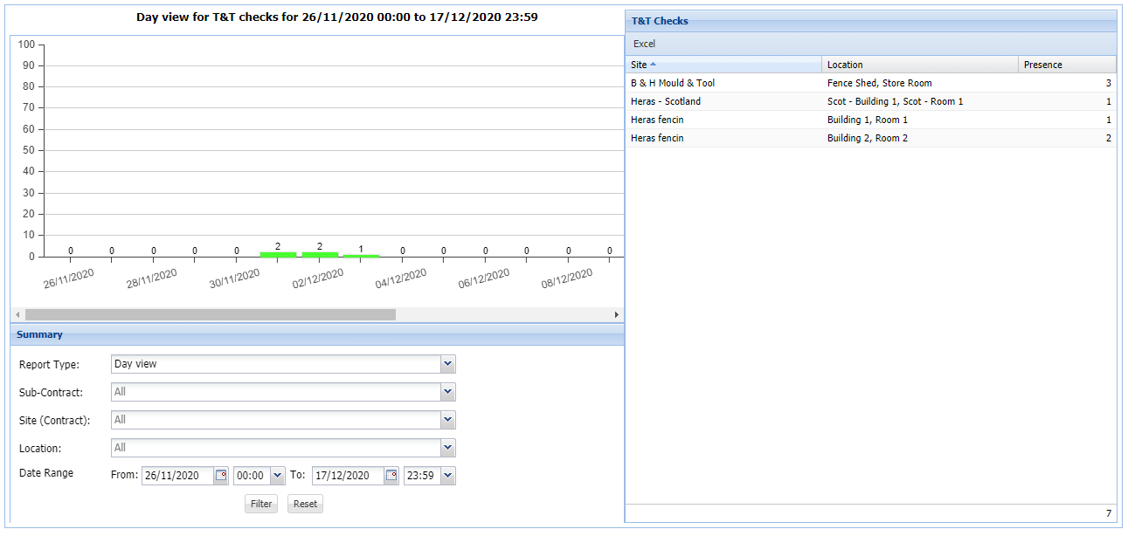

The filtering options are:

* **Report Type** - this will control the graph options which include:
  + **Day view** - days across for the date range selected
  + **Site view** - sites across for the date range selected
* **Sub-Contract** - this (optionally) enables selection of the sub-user
* **Site (Contract)** - this (optionally) enables a specific site to be selected
* **Location** – this (optionally) enables a specific location to be selected
* **Date Range** - this (optionally) enables Date Range including **time** selection. The **Date Range** will always default to that defined on **System Control** (see above). The **time** is set for 00:00 to 23:59 hours. When a **time** range is entered it will relate to the overall start- and end-point (i.e. 26/11/2020 06:00 to 28/11/2020 18:30)

The **T&T** panel (on the right side of the screen) shows a single row for each location with columns for **Site** (name), **Location** and **Presence** for the selected **Date Range**. i.e. the number of times that the location has been checked within the **Date Range** specified. Details will be displayed in **Site** and **Location** sequence, although it will be possible to re-sort any column.

By default, the graph will plot the **Presence** count by **Day**. This can be changed to show by **Site**, depending upon the selected Graph **Report Type**. When a column is selected, a subset of the data is shown on the right. Depending upon the Graph **Report Type** selected, this will be for a single **Day** or a single **Site**.

**Please Note**: A maximum of 90 days can be selected using the **Date Range**, due to the potentially large amount of data required in this area.

## Quick View

The **Quick View** option enables a more simplistic, unsecured method of viewing a calendar of completed and planned ‘services’ (workbills).

This can be accessed from the existing CP website, though it is intended that customers imbed a link directly to **Quick view** from their websites with a pre-set client code. In this way, they can allow direct access for their tenants to the appropriate information.

Should you be interested in using **Quick view** or would like more information, please contact TEAM Software.

## Sub-User Administration

Access to sub-user administration is restricted to the client’s administrator and will be available on all pages of Customer Portal, accessed by clicking the **Admin** menu item.

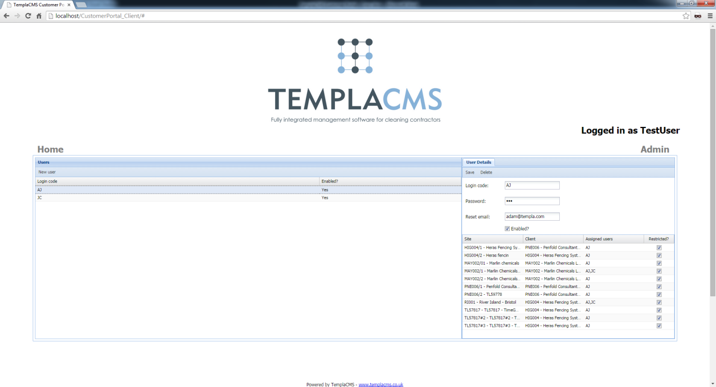

The client’s administrator will have access to add, amend and delete their sub-users allowing for multiple users for each client. Sub-users can be configured to only have access to certain sites within their portfolio.

**Please Note:** A sub-user will be unrestricted by default.

### Add sub-user



By clicking **New user** (on the toolbar at the top of the **Users** grid), enables the client’s administrator to enter all new sub-user details.

**Login code:** This is the **Login code** that the sub-user will use to log in to TemplaCMS Customer Portal.

**Password:** This is the **password** that the user will use to log in to TemplaCMS Customer Portal.

**Reset email:** This allows the user to set the email address that TemplaCMS will send a forgotten password to.

**Enabled:** This allows the user to set whether the sub-user can login to TemplaCMS Customer Portal (Defaults to True).

The user will be disallowed from saving the sub-user until all details above have been entered. To restrict sub-user access to specific sites, a grid of sites is available in the **User details.** If the **Restricted?** check-box is checked, then the sub-user will only see details in the system that belong to that specific site(s).

### Delete sub-user

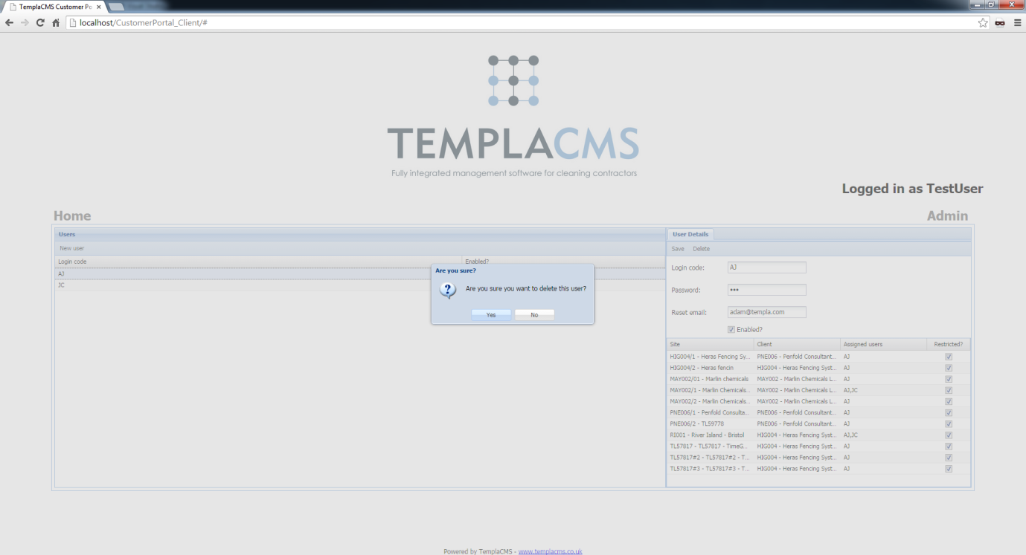

To delete a sub-user from TemplaCMS Customer Portal, highlight the user in the **grid** and click **delete** in the **User details**. A message will appear asking the user to confirm the deletion.

**Please Note:** Once the user has been deleted from the system they will not be able to log-in again under that user code.

## Logoff

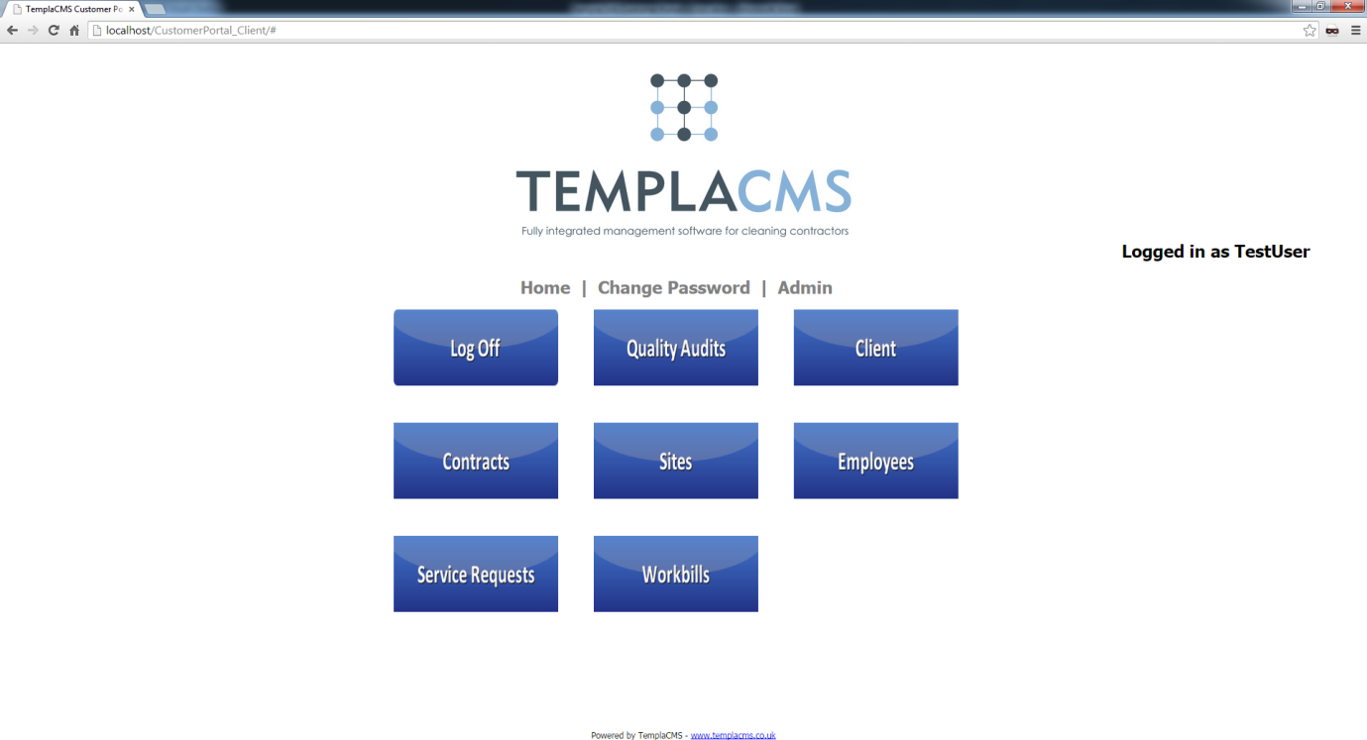

To **logoff** the TemplaCMS Customer Portal, navigate back to the home screen, by clicking the **Home** menu item, then click the **Log Off** button.

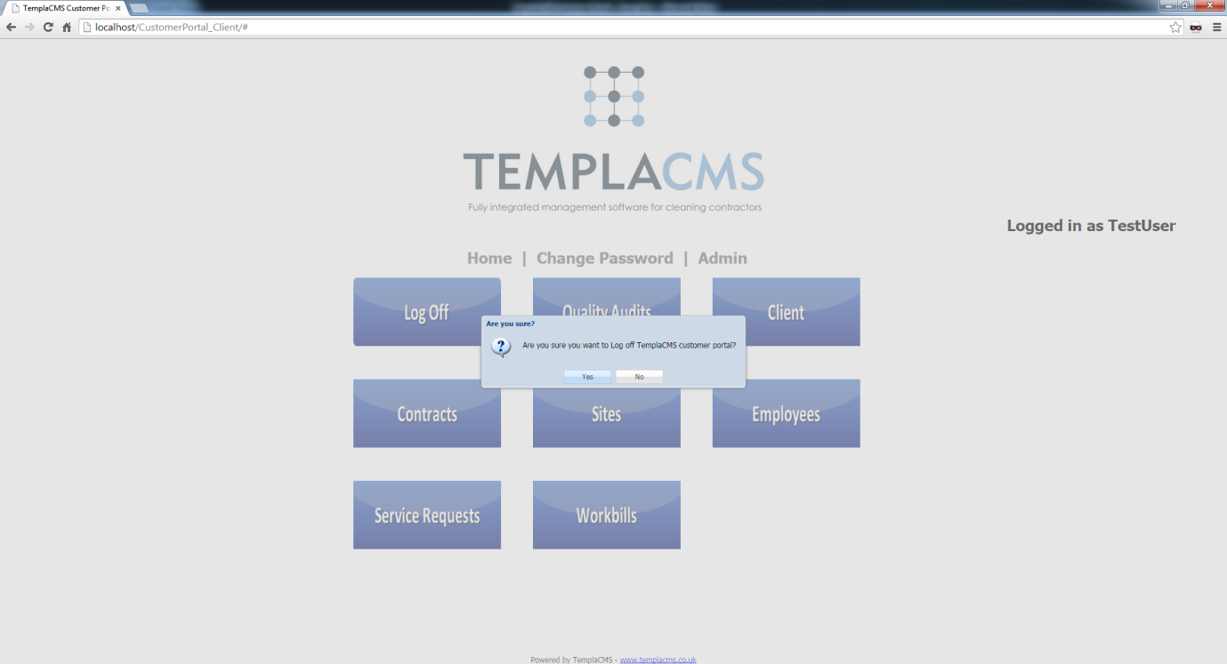

A message will appear asking whether the user would like to log off TemplaCMS Customer Portal. Click **Yes** to close the session and return to the **Home** screen.

